**Lab Report**

Title: Lab 2 Part 1

Notice: Dr. Bryan Runck

Author: Zhaoxu Sui

Date: 10/26/2021

**Project Repository: https://github.com/KennethSui/GIS5571/tree/main/lab2**

**Google Drive Link: https://drive.google.com/drive/folders/1qw0Werk9F63C6FkLkBe_iKm4xs2LZnQ1?usp=sharing**

**Time Spent:** 10 hours

**Abstract**

Firstly, I stitched together basic skills in API queries with raster, cube, TIN, and Terrain data transformation steps to create an extract, transfer, and load system for LiDAR data from the Minnesota DNR. After doing exploratory comparison, I used ArcPy to export to a PDF a visualization of LiDAR data. Also, I managed to use a set of BIL Data from PRISM FTP to make a space-time cube. However, I did not make it to export as an Animation.

**Problem Statement**

This time, I will be getting involved in ETL process, which stands for extract, transform, and load, a really crucial part for the GIS analysis. In order to better handle this knowledge, I will use the ETL to generate two different kinds of visualizations of both LiDAR data and BIL data via ArcPro and ArcPy.

*Sheet 1: Required Datasets for this lab task*

|  |  |  |  |  |  |  |
| --- | --- | --- | --- | --- | --- | --- |
| **#** | **Requirement** | **Defined As** | **(Spatial) Data** | **Attribute Data** | **Dataset** | **Preparation** |
| 1 | Lidar | A Lidar Sample File for converting and analyzing | LAS File |  | MN Geospatial Commons | Derived from Notebook |
| 2 | Raster Series | Annual 30-Year Normal Precipitations for making space-time cubes | BIL File |  | PRISM | Derived from Notebook |

**Input Data**

*Sheet 2: Input datasets*

|  |  |  |  |
| --- | --- | --- | --- |
| **#** | **Title** | **Purpose in Analysis** | **Link to Source** |
| 1 | 4342-12-05.las | A LAS file for converting into DEM and TIN that could being used to make visualization | [Mn GeoSpatial Commons](https://resources.gisdata.mn.gov/pub/data/elevation/lidar/examples/lidar_sample/) |
|  | PRISM_ppt_30yr_normal_4kmM2_all_bil | A BIL file for making timeseries animation | [PRISM](https://prism.oregonstate.edu/normals/) |

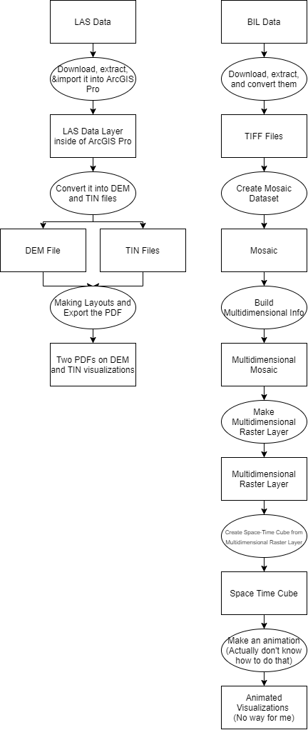

**Methods**

The whole process is programmed in the ArcGIS Pro notebook with the utilization of Arcpy functions as well as manual manipulations in the ArcGIS Pro.

Firstly, I located a example LAS file in the MN DNR and got it through the notebook. After importing the LAS file into the map, I converted it into both DEM file and TIN file. Then, I manually added two layouts and 1 map to visualize the DEM file and TIN file. Through Arc Notebook, I exported the layouts as pdf files.

Secondly, I compared the visualizations of LAS file in both the format of DEM and TIN. I put the exploratory analysis in the discussion part.

Lastly, I downloaded the BIL file for a 30-year period of annual precipitation. Importing the file into Arc, converted to Space Time Cube, but failed to generate an animated series.

**Results**

Both the Export PDFs and Space Time Cube file were generated successfully. However, since many people have difficulties making animated gif, I decided not to spend time on this one. However, if it is still required, I will make it possible in the next week.

**Results Verification**

Both the DEM and TIN files are successfully visualized and exported. Despite the result message in the Jupyter notebook, I also put images here for validate the results.

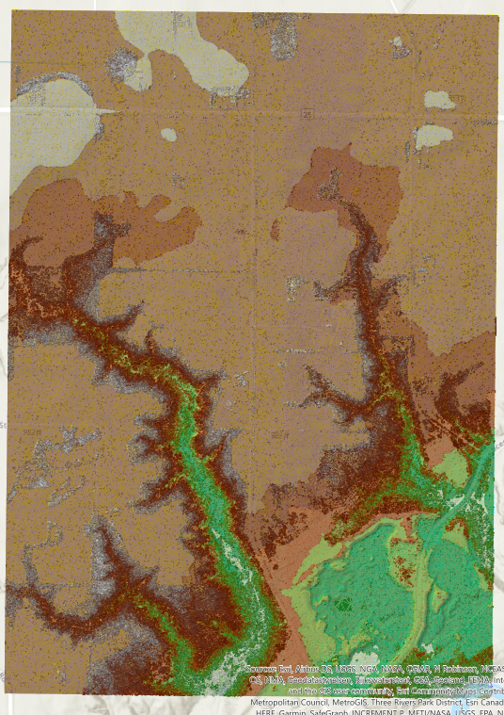

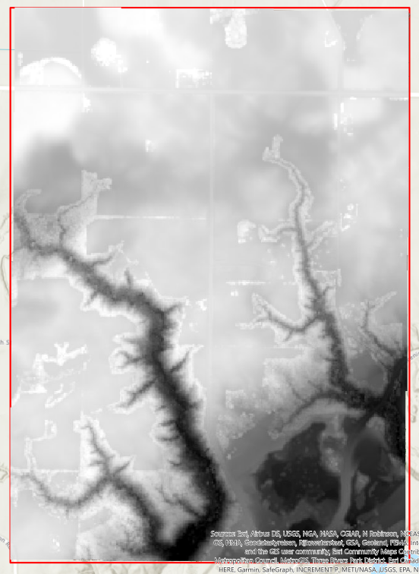

Figure 1 Map showing the multidimensional feature layer of TIFFs, with timeframe bar on the upperright.

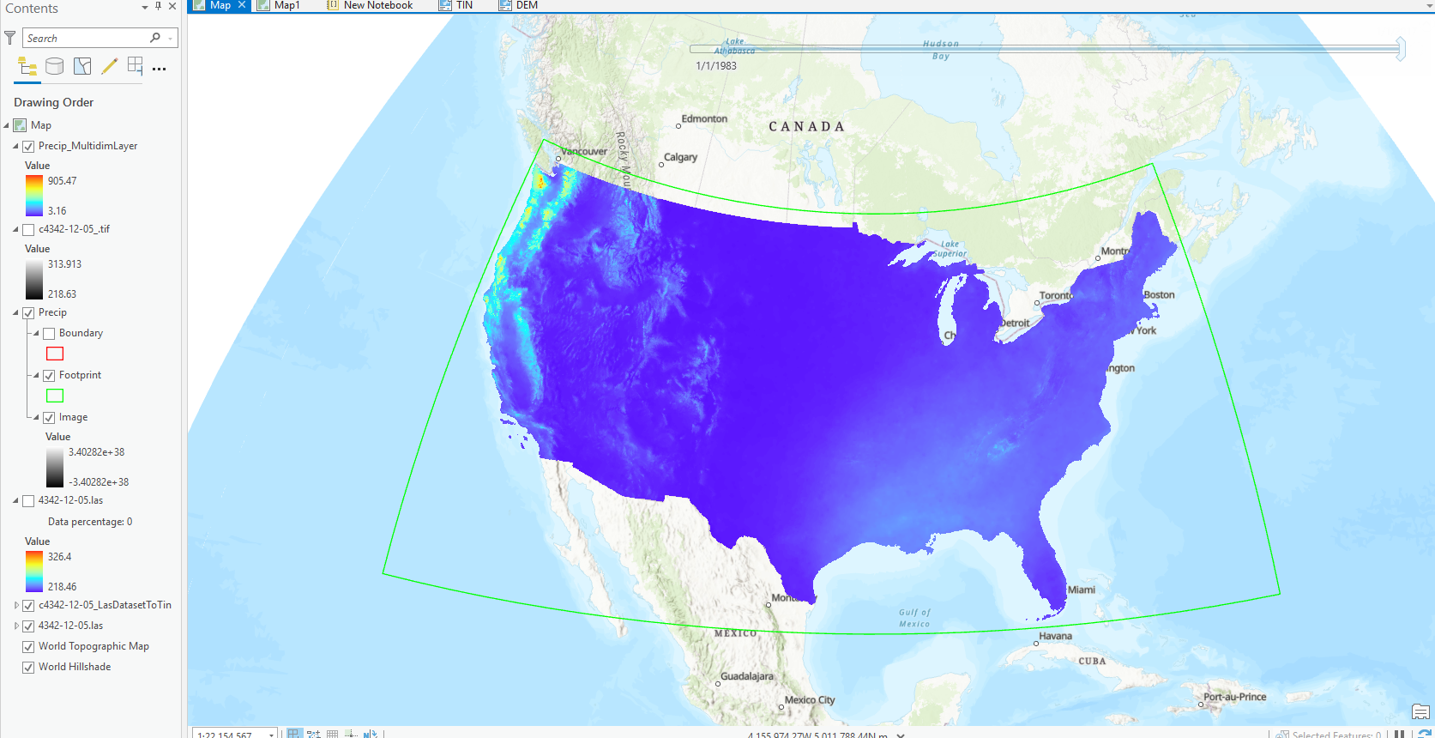

Figure 2 The success messages was embedded in the notebook.

**Discussion and Conclusion**

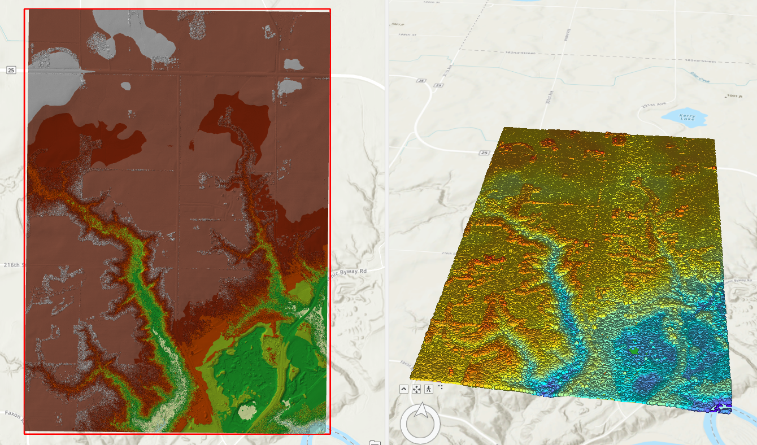

By comparing the visualizations of LAS file in 2D and 3D, I found that those points in the 2D surface is really difficult to view under a really small scale, so there is only the TIN layer and DEM layer visible in the left image. However, those points in the 3D view are more straightforward and represent their relative elections. Both 2D view and 3D view of this layer used a gradient color scheme.

In this part, I learned how to create an ETL process for conducting basic operations. I also learned how to use the BIL file and export it into an space-time cube file.

**References**

PRISM Gridded Climate Data Public Downloads via Web Service. PRISM. Last Retrieved in 2021. https://prism.oregonstate.edu/documents/PRISM_downloads_web_service.pdf

PRISM Gridded Climate Data – Bulk Downloads. PRISM. Last Retrieved in 2021. https://prism.oregonstate.edu/documents/PRISM_downloads_FTP.pdf

Explore your raster data with Space Time Pattern Mining. Lynne Buie, Esri. Last Retrieved in 2021. https://www.esri.com/arcgis-blog/products/arcgis-pro/analytics/explore-your-raster-data-with-space-time-pattern-mining/

**Self-score**

*Fill out this rubric for yourself and include it in your lab report. The same rubric will be used to generate a grade in proportion to the points assigned in the syllabus to the assignment.*

|  |  |  |  |
| --- | --- | --- | --- |
| **Category** | **Description** | **Points Possible** | **Score** |
| **Structural Elements** | All elements of a lab report are included **(2 points each)**:  Title, Notice: Dr. Bryan Runck, Author, Project Repository, Date, Abstract, Problem Statement, Input Data w/ tables, Methods w/ Data, Flow Diagrams, Results, Results Verification, Discussion and Conclusion, References in common format, Self-score | 28 | **25** |
| **Clarity of Content** | Each element above is executed at a professional level so that someone can understand the goal, data, methods, results, and their validity and implications in a 5 minute reading at a cursory-level, and in a 30 minute meeting at a deep level **(12 points)**. There is a clear connection from data to results to discussion and conclusion **(12 points)**. | 24 | **22** |
| **Reproducibility** | Results are completely reproducible by someone with basic GIS training. There is no ambiguity in data flow or rationale for data operations. Every step is documented and justified. | 28 | **27** |
| **Verification** | Results are correct in that they have been verified in comparison to some standard. The standard is clearly stated **(10 points)**, the method of comparison is clearly stated **(5 points)**, and the result of verification is clearly stated **(5 points)**. | 20 | **19** |
|  |  | 100 | **93** |